Berkeley papers lab Solution

Student ID - 24235415
Name - Meenakshi

1. Is the research original, novel and important to the field? Has the appropriate structure and language been used? Why? (page 1-4)

Answer-: Yes, both research papers are original. It was written in 2009 having formal and clear tables, predictions and headlines with proper explanation. It explains clearly about three services that are IaaS ,SaaS and Paas. Which are the pillars of cloud computing. The main writer of this paper clearly gave us the idea of the evolution of cloud computing and its services. Like how its going to be on-demand service , how we are going to utilize it like similar to how we use electricity, where we only have to pay for what we consume. Nothing extra, just the used amount is deducted from us like that only cloud will change everything and it will be efficient and sustainable.

2. Comment on whether you agree (and why) with their prediction that FAAS will become more dominant than IAAS.

Answer-: First of all Faas is not directly mentioned in the document as it says about serverless computing. As it needs less manual intervention and day to day maintenance. It is secure and easy to handle. It is not like other EC2 kind of resources which need manual intervention or handling of other attached resources.
As it is a clear hint by the writer that people will use serverless rather than infrastructure based resources. So, this is the clear reason for supporting the point that function as a service will become more dominant than infrastructure as a service.

3. Identify the issues they claim have limited the existing model of Cloud Computing since 2009.(page no 14-18)

Answer-: In the paper the main limitations of cloud services are as follows -:
- The difficulty level of managing the resources and keep them running throughout.like its written no single source of failure.
- They need to handle servers, provisioning of them ,utilization of resources and scaling manually.
- At the end they have to manage the cost of resources which needs to be reduced.And this also the point where serverless computing comes into picture to tackle some of the manual workloads.
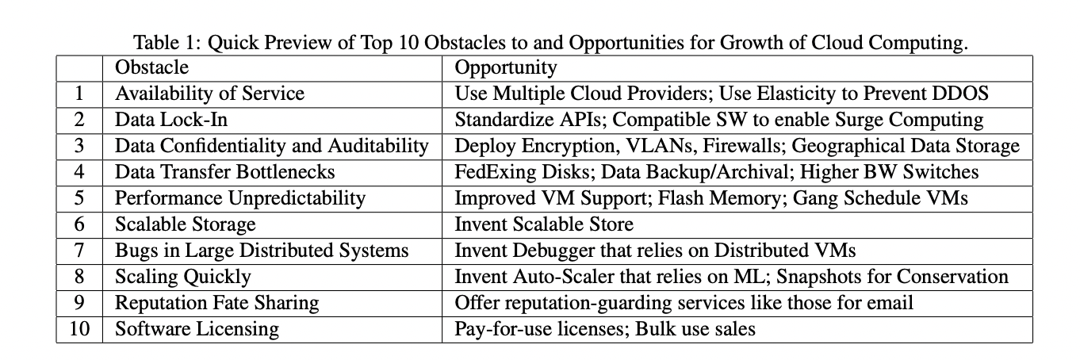

Fig.1.1 reference from Paper which points out the obstacles while growing in cloud.

4. Identify what they believe is needed for FAAS to become as dominant as they predict.

Answer-: For serverless computing to become as dominant as predicted,

- The cloud platform resources must handle things itself rather than any manual intervention.
- Also the function should start faster rather than booting up slower

5. Distinguish between the Current Server model and Serverless.
(Page no 19)
Answer-: Current server model is basically the infrastructure which are managed manually and we have to pay for allocated servers. Related to the application as it have to run continuously on servers due to which we may face slower time in scalability. That too is manual.

In serverless, we don’t have to struggle to manage the resources as it is not manual and the billing is done only for the total execution time. Also the scaling is automated and its more efficient that current server model.

6. What are the benefits of Serverless Computing to Cloud Providers and Consumers.

Answer-:
1. Benefits of serverless computing to Cloud Providers:
- Resource Utilization: full server usage is reduced as the functions are executed only when needed.
- Automatic Scaling: As previously mentioned there is automatic scaling with no human intervention for it.
- Less Operational Costs: As the servers are only up when they are in use. So, cost is reduced.
2. Benefits to Cloud Consumers:
- Focuses on Code, Not the Infrastructure: For cloud consumers they only focus on code not much on infrastructure as the cloud platform provides multiple services to make the application run easily.
- Cost-Effective: As it follows pay per use terms so we only have to pay for the execution time.

